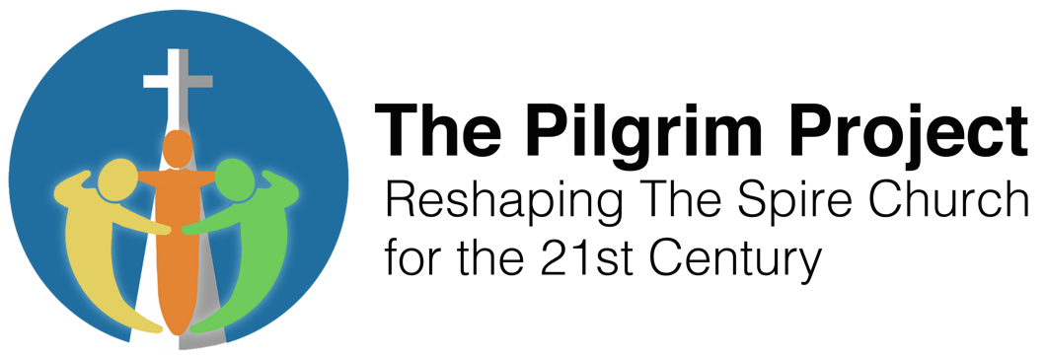
ZOOM Quiz Night and two-course meal from COOK (optional)

Dear Friends,
Thank you for your interest in for our fundraising Zoom quiz on the 13th November. The cost of the tickets includes a main meal and dessert from COOK, and chocolate. Please join us for the quiz even if you do not wish to have the meal, at a reduced ticket cost.
We have an experienced Quiz Master, Graham Noakes.
The quiz will be over 5 rounds, which includes a picture round, which will run throughout the evening. After round 2 we will break for the meal. The meal is can be cooked from frozen.
You are invited to participate in teams of up to 8. Each team will be able to privately discuss and agree their answers in a breakout room before returning to the group session to hear the answers, note their score and hear the questions for the next round. Each team will be asked to submit their score by the use of the chat facility.
As long as you can connect to Zoom we will take care of the switching in and out of the breakout rooms and will have a helpline available during the evening if anyone has any Zoom problems.
Full instructions and help will be given prior to the start of the quiz.
The idea is that you have a dinner party type evening with your friends, or if that is not possible for you all to get together you can still be a team, but in different houses.
During the meal we will switch you back into your breakout rooms to be able to chat and discuss the picture round.
The meal can be collected from the Spire church (URC building) South Street Farnham, GU9 7QU on the morning of the Quiz, (more details later).
The meal choices are;
Main meal
Beef Lasagne
Vegan: Shepherdless pie (contains red wine)
Vegetarian: Roast veg Lasagne
Gluten-Free: Cottage pie
Dessert:
Belgian Chocolate Brownie
Gluten-free: Belgian Chocolate Brownie
Vegan: Farmhouse Flapjack

Please provide by the 25 October the following;
- Number and choice of meals per team.
- Whether there are any single meals.
- The team name
- Name, email address and contact telephone number of the team leader. This person will receive the Zoom link.
- The number of people in the team and the number of devices e.g. Laptop, iPad being used.
- We are also able to process individual applications, but dealing with the team captain of a team will make admin easier.
You can pay for your tickets by bank transfer, cash or cheques, made payable to Farnham United Reformed Church are also acceptable. Cash can be paid in at the Spire Café and cheques can either be paid in there or posted to Spire church (URC building) South Street Farnham, GU9 7QU. Please mark the envelope Quiz Evening.
The bank details are as follows;
The Royal Bank of Scotland
Account name; Farnham United Reformed Church current Account
Sort code; 16-19-26
Account number; 10585554
Reference; Quiz
Payment is required before 25 October please.

Further information and the Zoom link will be provided nearer the time.
If you have any questions please do not hesitate to contact us at: fundraising@pilgrimproject.org.uk
Thank you for supporting the fundraising for the Pilgrim Project.
The Pilgrim Project Fundraising Committee

